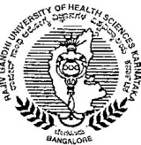
Rajiv Gandhi University of Health Sciences, Karnataka
4th T Block, Jayanagar, Bangalore – 560 041
RGU:Adv.Research:2015-16 Date:13-01-2016
CIRCULAR

Lady Tata Grant for Medical Research has invited applications for award of research grants in India for any scientific investigation having a bearing, directly or indirectly, on the alleviation of human suffering from diseases. The application form can be downloaded from www.trialect.com. Further information about this grant release can be had from https://app.trialect.com/3124/display
The last date for applying is 25th January 2016.
Interested teaching faculty affiliated to RGUHS is requested to make use of this opportunity.
Sd/-
Director
Advanced Research, RGUHS

